Project - High Level Design
On
Telecomm Support Triage Agent
Course Name: Agentic AI

Institution Name: Medicaps University – Datagami Skill Based Course

Student Name(s) & Enrolment Number(s):
Sr no | Student Name | Enrolment Number
1 | ANKIT YADAV | EN22CS301136
2 | ANSHUMAN GEETE | EN22CS301160
3 | ARTI JAIN | EN22CS301206
4 | ATISHA JAIN | EN22CS301235
5 | AVANI SHARMA | EN22CS301239
6 | ISHANA HATODIYA | EN23CS3L1011

Group Name: 07D2
Project Number: AAI-19
Industry Mentor Name: Aashruti Shah
University Mentor Name: Ajeet Singh Rajput
Academic Year: 2022-2026

- Introduction :
The Telecomm Support Triage Agent is an AI-powered system designed to automate the initial handling of customer support queries in the telecommunications domain. It leverages Large Language Models along with agentic frameworks such as LangChain or CrewAI to intelligently classify incoming messages, extract important entities, and generate contextual draft responses.
This system helps reduce manual effort, improves response time, and ensures efficient prioritization of customer issues.

  - Scope of the document :

This document provides a high-level architectural overview of the Telecomm Support Triage Agent system. It includes system design, components, workflows, APIs, and key design considerations required for implementation.

  - Intended Audience :

- Developers and Engineers
- Project Mentors and Evaluators
- AI/ML Engineers
- System Architects
- Students and Researchers

  - System overview :
The system processes incoming customer messages and performs the following tasks:
- Classifies the query based on urgency and intent
- Extracts key entities (Customer ID, Issue Type, Date, etc.)
- Generates an AI-based draft response
- Routes the query to appropriate support teams

The system integrates LLM APIs with agent frameworks to create a reactive and intelligent triage workflow.

- System Design :
The system follows a modular and scalable architecture:
- Frontend Layer: User interface or API endpoint for receiving messages
- Processing Layer: Handles classification, NER, and response generation
- Agent Layer: Manages workflow orchestration using LangChain/CrewAI
- LLM Layer: External API for NLP tasks
- Data Layer: Stores logs, queries, and responses

  - Application Design :
The application is designed using a pipeline-based approach:
- Input ingestion
- Preprocessing
- Classification module
- Entity extraction module
- Response generation module
- Output delivery
Each module works independently and communicates via APIs.

  - Process Flow :

- User sends a support query
- System receives and preprocesses the text
- Classification model determines urgency and intent
- NER module extracts key entities
- Agent decides next action
- LLM generates a response draft
- Response is sent or routed

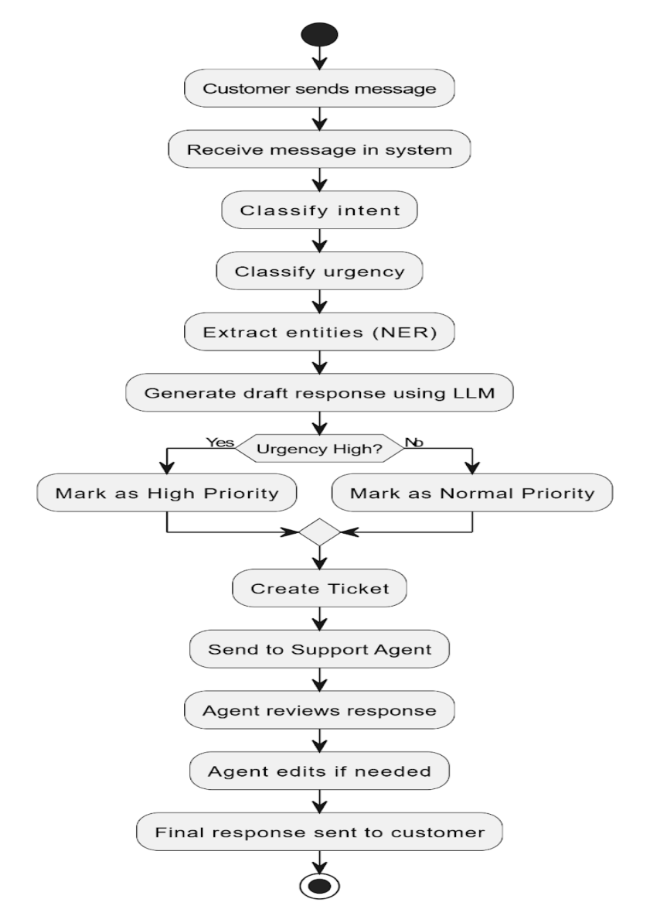

  - Information Flow :

Input → Preprocessing → Classification →
Entity Extraction → Agent Decision → Response Generation → Output

  - Components Design :

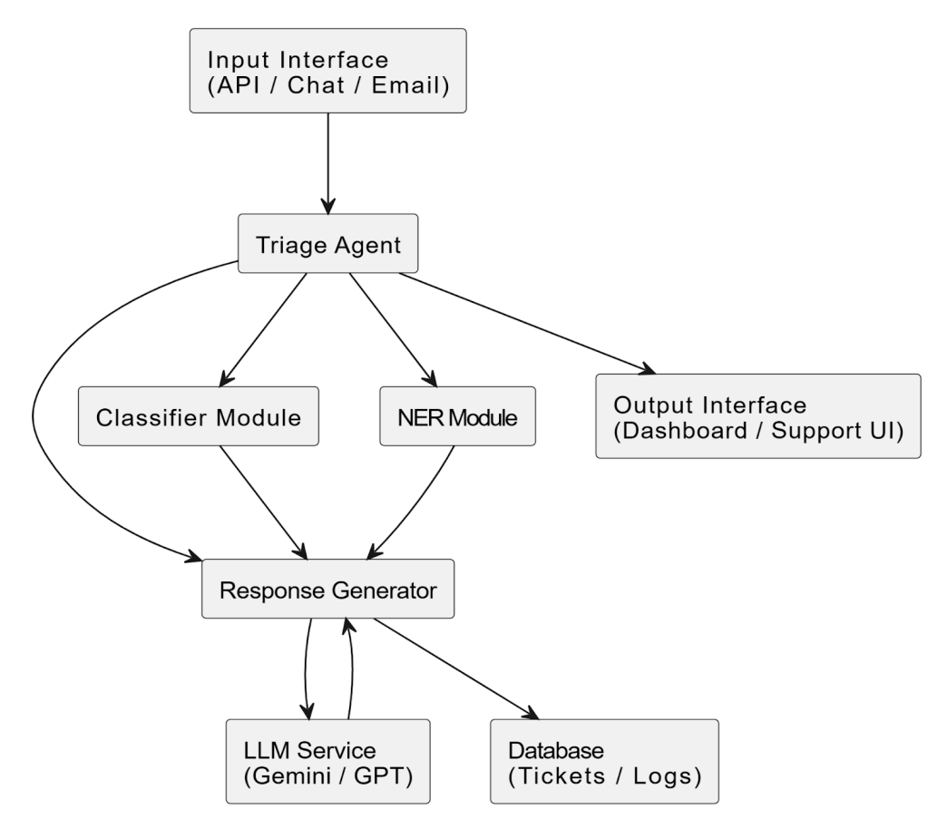

- Input Handler: Receives incoming queries
- Classifier: Categorizes queries (urgent, normal, low priority)
- NER Module: Extracts structured information
- Agent Controller: Controls workflow execution
- LLM Interface: Communicates with external AI models
- Response Generator: Creates human-like responses
- Database: Stores logs and processed data

  - Key Design Considerations :
- Scalability for handling large volumes of queries
- Low latency for real-time response
- Accuracy in classification and entity extraction
- Secure handling of user data
- Modular design for easy updates

  - API Catalogue :
- /receive-query → Accepts incoming message
- /classify → Returns urgency and intent
- /extract-entities → Extracts structured data
- /generate-response → Generates AI response
- /route-query → Assigns to support team
- Data Design :

  - Data Model :

- User Query
- Query Type
- Priority Level
- Extracted Entities
- Generated Response
- Timestamp

  - Data Access Mechanism :

- REST APIs
- Database queries

  - Data Retention Policies :

- Store logs for analysis
- Sensitive data anonymization
- Compliance with data privacy policies

  - Data Migration :

- Not required initially
- Can be implemented when scaling system

- Interfaces :

- REST API interface
- LLM API integration
- Optional UI dashboard

- State and Session Management :
- Stateless API design
- Session tracking via request IDs
- Logs maintained for traceability
- Caching :

- Cache frequent queries
- Reduce API calls to LLM
- Improve response time
- Non-Functional Requirements :

- High availability
- Scalability
- Reliability
- Maintainability
- Usability

  - Security Aspects :

- API authentication
- Data encryption

- Secure API communication
- Role-based access control

  - Performance Aspects :

- Fast response generation
- Optimized API calls
- Efficient processing pipeline
- Load handling capability

- References :

- LangChain Documentation
- CrewAI Documentation
- OpenAI / LLM API Docs
- NLP and NER research papers

